**Substituted (E)-1-(furan-2-yl)-3-phenylprop-2-ene-1-one**.

(E)-1-(furan-2-yl)-3-phenylprop-2-ene-1-one and its *p*-substituted compounds were prepared by the following procedure67SP.

The mixture of the calculated amount of the pure 2-acetylfuran (0.55g ~ 0.005 moles) in cold ethanol and 10% solution of sodium hydroxide (catalytic amount) was cooled in a water bath to 0o C. To this mixture pure benzaldehyde (0.583 g ~ 0.0055 moles) in cold ethanol was added drop by drop for 30 minutes. The reaction mixture stirred for 2 hours. Then it was kept in the refrigerator for overnight. The precipitated solid was collected and recrystallized using ethanol-chloroform (10:1) mixture.



Scheme ()

All the substituted compounds were prepared by using the above procedure.

**Characterization**

All the compounds were characterized as (E)-1-(furan-2-yl)-3-phenylprop-2-ene-1-one and its derivatives by 1H and 13C NMR spectral techniques. All 1H and 13C NMR spectra were obtained on a BRUKER AV 400 MHz spectrometer. Chemical shifts of 1H were measured with the central peak of CDCl3 at δ 7.259 as the internal reference, while those of 13C were measured with the central peak of CDCl3 at δ 77.54 as the internal reference.



Fig.(1)

where X is the substituents viz. *p*-NMe2, *p*-Me, H, *p*-Cl, *p*-F, *p*-CHO.

In 1H NMR spectra of (E)-1-(furan-2-yl)-3-phenylprop-2-ene-1-ones whose signals assignment were not difficult and all signals well separated from each other. The -CH- proton of C11 carbon atom is expected to downfield than -CH- proton of C9 carbon atom. The -CH- proton of C10 is well separated from all other protons signals, hence it’s assignment is not difficult. Two ethylenic protons C6 and C5 carbon atoms are well separated from each other. The α-ethylenic proton is expected to be downfield shift since it is proximity to the carbonyl group. Assignment of the signals was based on splitting pattern and peak integration ratio. 1H NMR spectra of (E)-1-(furan-2-yl)-3-phenylprop-2-ene-1-ones are given in Fig’s (2-7).

**1H NMR spectra of (E)-1-(furan-2-yl)-3-phenylprop-2-ene-1-ones are given below.**

1. **(E)-1-(furan-2-yl)-3-(4’ -N,N dimethylaminophenyl)prop-2-ene-1-one:**

**δ** 3.043(s,6H), 6.562 (d,d,1H), 6.690 (d,2H), 7.256 (d,1H), 7.262 (d,1H),7.554

(d,2H), 7.616 (m,1H), 7.856 (d,1H).

1. **(E)-1-(furan-2-yl)-3-(4’ -methylphenyl)prop-2-ene-1-one:**

**δ**

1. **(E)-1-(furan-2-yl)-3-phenylprop-2-ene-1-one:**

**δ** 6.600 (d,d,1H), 7.336 9d,1H), 7.421(m.2H), 7.423 (d,1H), 7.456(d,1H), 7.655(m,2H),

**7.**657(m,1H), 7.885(d,1H).

1. **(E)-1-(furan-2-yl)-3-(4’-chlorophenyl)prop-2-ene-1-one:**

**δ** 6.606(d,d,1H), 7.339(d,1H), 7.394(d,2H), 7.425(d,1H), 7.584(d,1H), 7.584(d,2H),

7.658(m,1H), 7.822(d,1H).

1. **(E)-1-(furan-2-yl)-3-(4’ -fluorophenyl)prop-2-ene-1-one:**

**δ** 6.599 (d,d,1H), 7.107(m,2H), 7.329(d,1H), 7.380(d,1H), 7.642(m,2H), 7.650(m,1H), 7.837(d,1H).

1. **(E)-1-(furan-2-yl)-3-(4’ -oxophenyl)prop-2-ene-1-one:**

**δ**

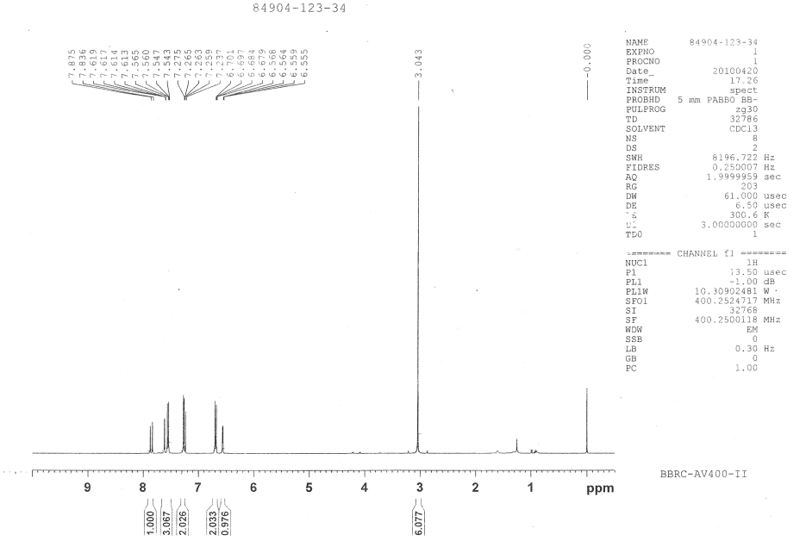

**Fig 1H NMR spectra of (E)-1-(furan-2-yl)-3-(4’ -N,N dimethylaminophenyl)prop-2-ene-1-one**

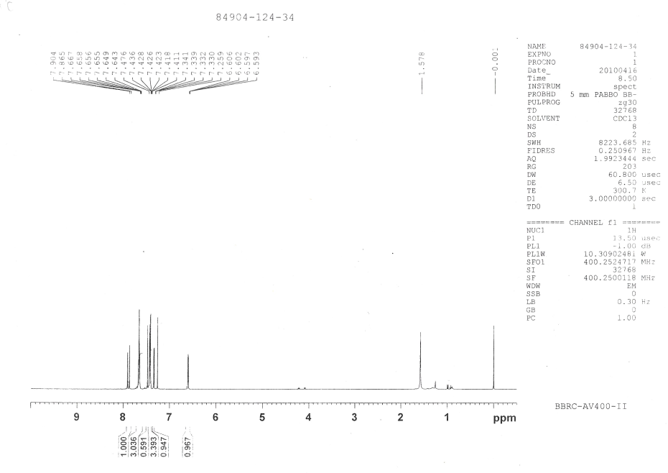

**Fig**. **1H NMR spectra of (E)-1-(furan-2-yl)-3-phenylprop-2-ene-1-one**

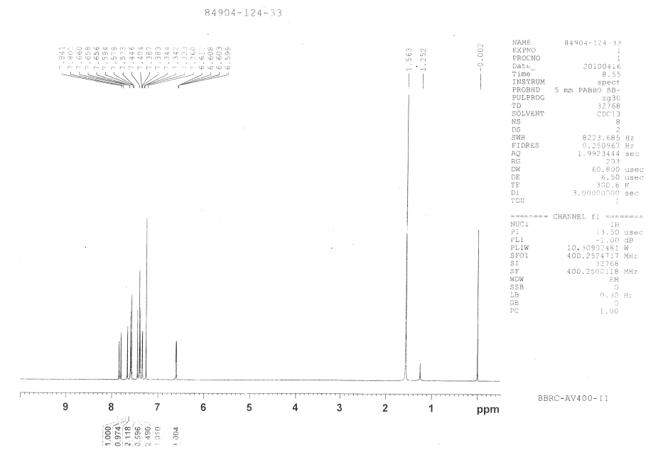

**Fig.** **1H NMR spectra of (E)-1-(furan-2-yl)-3-(4’-chlorophenyl)prop-2-ene-1-one**

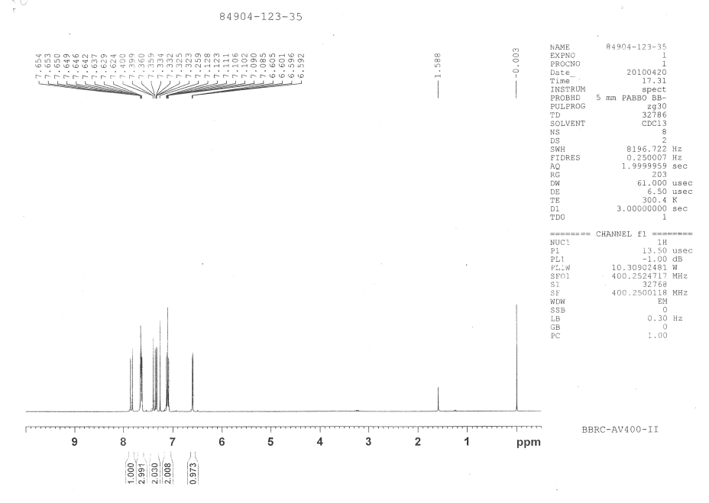

**Fig .** **1H NMR spectra of**  **(E)-1-(furan-2-yl)-3-(4’ -fluorophenyl)prop-2-ene-1-one**

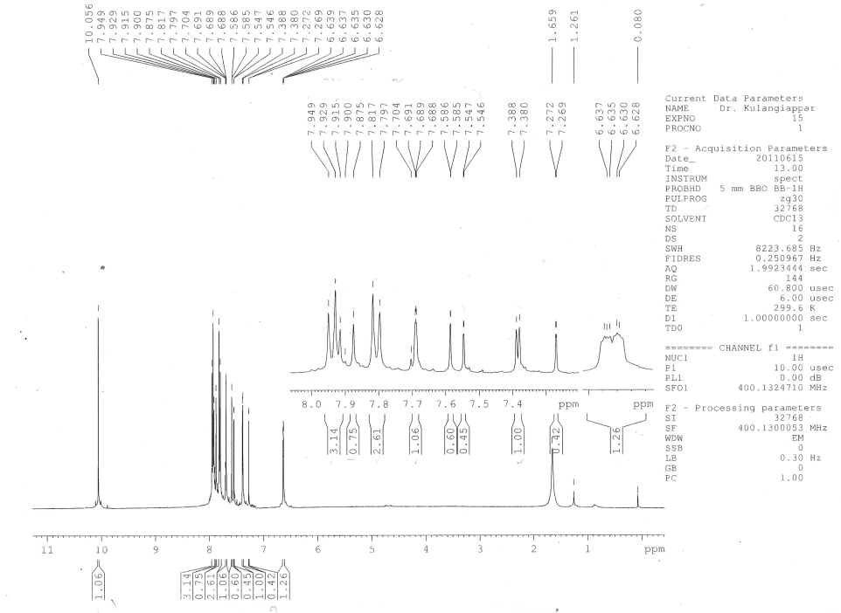

**Fig.**   **1H NMR spectra of (E)-1-(furan-2-yl)-3-(4’ -oxophenyl)prop-2-ene-1-one**

**Assignment of 13C NMR signals**

13C NMR signals were assigned for various carbons were based on the

1. Chemical shift exhibited by the signals
2. Relative signal intensity,
3. Empirical additivity rules.

The proton noise decoupled spectrum of parent compound contains 11 signals corresponding to 11 different carbon atoms. In all the spectra, carbonyl carbon signal was readily recognized from its low intensity and also well separated from other signals to the downfield extreme, since its assignment was not difficult.

Two more low-intensity peaks were readily assigned for C8 and C4 carbon atoms. Due to nearby oxygen atoms in the ring the downfield signal at 153.73 ppm was assigned for C8 carbon atom. The upfield signal at 134.75 ppm was assigned for C4 carbon atom.

There are remaining eight signals for eight carbon atoms in which, six signals appeared almost same intensity other two signals appeared twice in intensity. This is due to the number of protons attached to the sp2 carbon atoms. The two high-intensity signals were readily assigned for aromatic carbon C3,3’ and C2,2’ atoms. This is due to the styrene as substituent since the upfield signal is 128.54 ppm was assigned for (*ortho*) C2,2’ carbon atom and next downfield signal at 128.96 ppm was assigned for (*meta*) C3,3’ carbon atom.

There are remaining six same intensity signals in which most downfield extreme signals at 146.53 ppm was assigned to C11 carbon atom of furon ring because it is directly attached to the oxygen atom.

Among the remaining downfield signals of the two upfield signals were assigned for C9 and C10 carbon atoms. The signal at 117.52 ppm was assigned for C9 carbon atom and the signal at 112.56 ppm was assigned to C10 carbon atom.

There are remaining three signals in which the signal at 121.20 ppm was assigned for aromatic C1 (*para*) carbon atom.

Remaining other two signals were assigned for (Cβ) C5 and (Cα) C6 carbon atoms. The downfield signal at 144.00 ppm was assigned for C5 carbon atom and the upfield signal at 130.62 ppm was assigned at 130.62 ppm was assigned for C6 carbon atom, this is due to the π-bond polarization α, β unsaturated carbonyl compound.

In *para* substituted derivatives assignments of the benzene ring (C3,3’, C2.2’, C4, C1) carbon signals and C6, C8 carbon signals somewhat ambiguous in nature, which has been removed by empirical additivity rules (Appendix-I) and relative intensity. The 13C NMR chemical shift data for *para*-substituted (E)-1-(furan-2-yl)-3-phenylprop-2-ene-1-ones (Fig. ) are listed in table ().

**Table ( ): 13C NMR Chemical shifts of p-substituted E-(1)-(furan-2-yl)-3-phenylprop-2-ene-1-ones.**

|  |  |  |  |  |  |  |  |  |  |  |  |  |
| --- | --- | --- | --- | --- | --- | --- | --- | --- | --- | --- | --- | --- |
| **S.No.** | ***p*-X** | **C1** | **C2,2’** | **C3,3’** | **C4** | **C5** | **C6** | **C7** | **C8** | **C9** | **C10** | **C11** |
| 1 | **-**NMe2 | 154.26 | 111.82 | 130.53 | 122.54 | 144.86 | 116.38 | 178.29 | 152.10 | 115.94 | 112.28 | 145.86 |
| 2 | **-**CH3 | 131.74 | 128.28 | 129.41 | 140.89 | 119.89 | 143.80 | 177.88 | 153.52 | 117.01 | 112.20 | 146.10 |
| 3 | **-**H | 121.20 | 128.54 | 128.96 | 134.75 | 144.00 | 130.62 | 178.03 | 153.73 | 117.52 | 112.56 | 146.53 |
| 4 | -Cl | 153.64 | 129.67 | 129.25 | 133.26 | 142.48 | 121.63 | 177.76 | 136.52 | 117.65 | 112.65 | 146.61 |
| 5 | **-**F | 153.70 | 116.24 | 116.02 | 120.93 | 142.66 | 130.44 | 177.85 | 130.40 | 117.49 | 112.60 | 146.52 |
| 6 | **-**CHO | 140.13 | 129.90 | 128.63 | 137.03 | 123.68 | 141.75 | 177.17 | 153.23 | 117.77 | 112.50 | 146.58 |

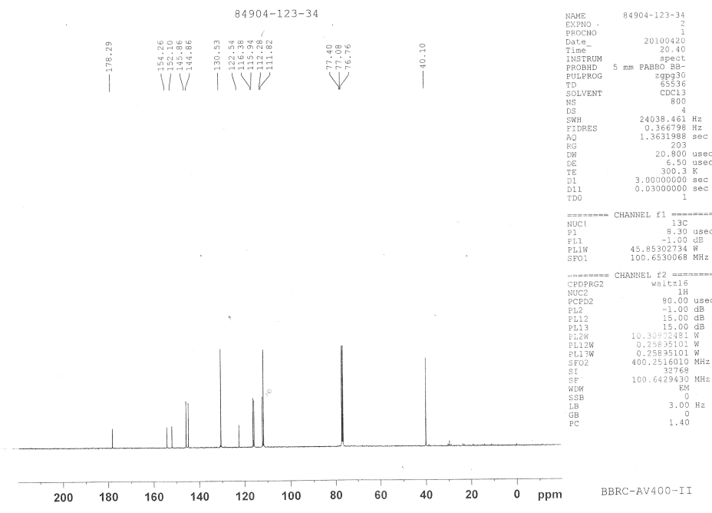

**Fig. 13C NMR spectra of (E)-1-(furan-2-yl)-3-(4’ -N,N dimethylaminophenyl)prop-2-ene-1-one**

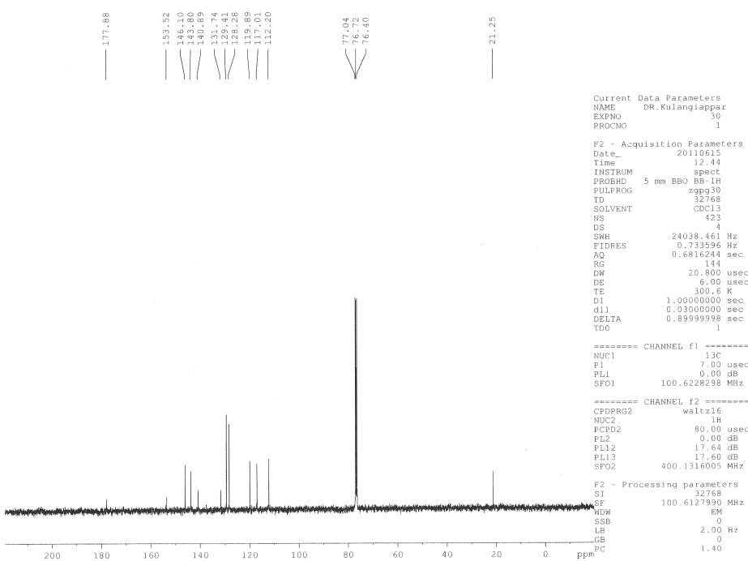

**Fig 13C NMR spectra of (E)-1-(furan-2-yl)-3-(4’ -methylphenyl)prop-2-ene-1-one**

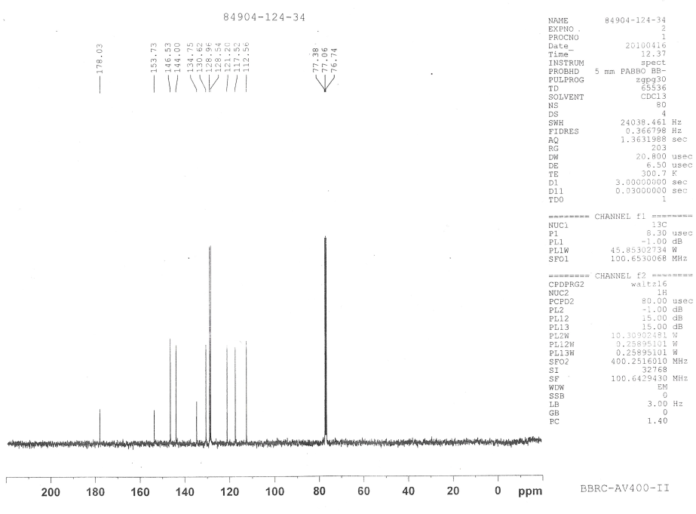

**Fig. 13C NMR spectra of (E)-1-(furan-2-yl)-3-phenylprop-2-ene-1-one**

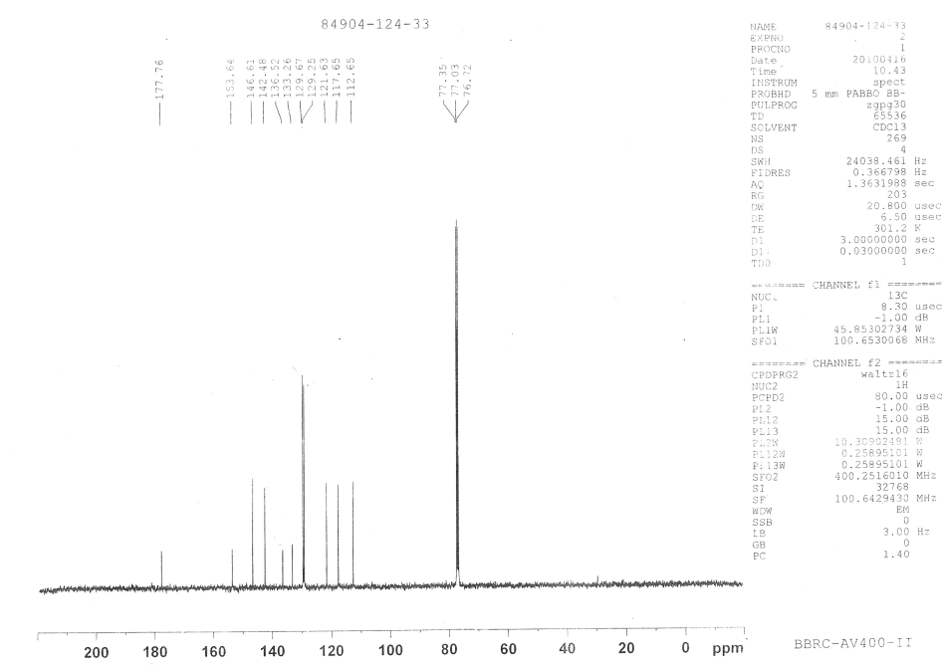

**Fig.** **13C NMR spectra of (E)-1-(furan-2-yl)-3-(4’-chlorophenyl)prop-2-ene-1-one**

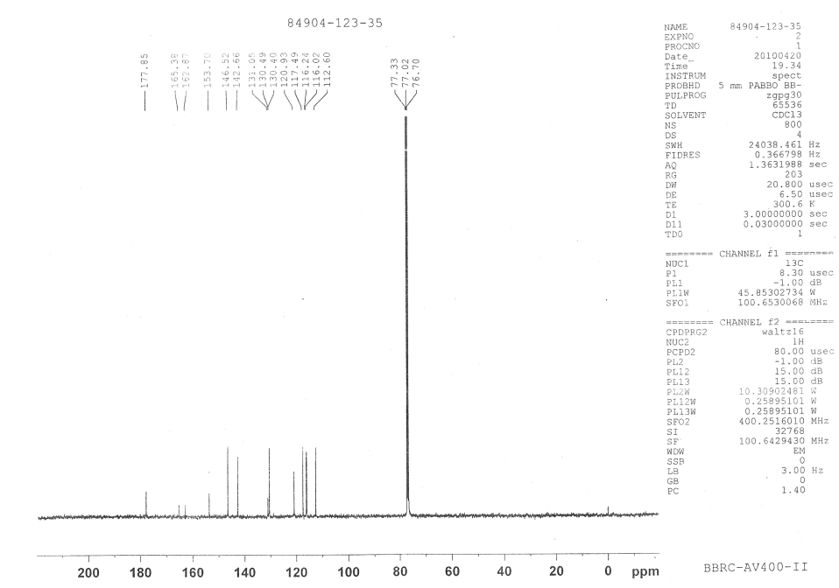

**Fig.** **13C NMR spectra of**  **(E)-1-(furan-2-yl)-3-(4’ -fluorophenyl)prop-2-ene-1-one**

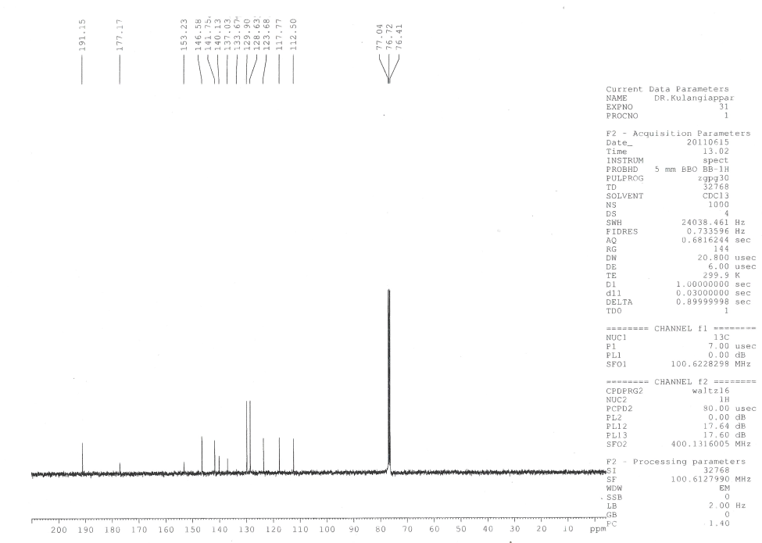

**Fig. 13C NMR spectra of (E)-1-(furan-2-yl)-3-(4’ -oxophenyl)prop-2-ene-1-one**